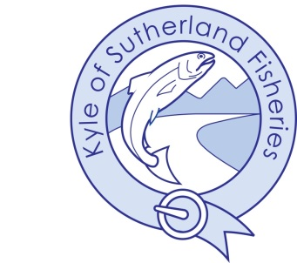
Kyle of Sutherland District Salmon Fishery Board

Annual Meeting of Qualified Proprietors
Friday 13th June 2025 at 9.30am
Kyle Fisheries Office, Ardgay & by Video Conference

AGENDA

- Welcome & Apologies
- Minutes of Meeting held 13th June 2024 – Approval and Adoption
- Action Points & Matters Arising
- Chairman’s Report
- Statutory Annual Report 2024– including activities of the Board for the year to date and proposed activities for 2025
- Adoption of draft accounts to year end 31st December 2024
- AOCB

