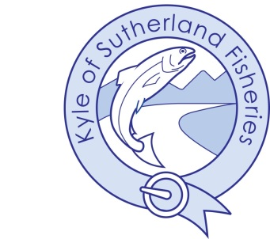
Kyle of Sutherland District Salmon Fishery Board
Ordinary Meeting
Friday 13th June 2025 at 1030am
At Ardgay office and by Video Conference

AGENDA

- Welcome & Apologies
- Minutes of Ordinary Meeting held Friday 28th March 2025
      - Adoption & Approval
      - Actions and Matters Arising
- Standard Items
      - Declarations of interest in agenda items to be discussed
      - Health & Safety
      - Complaints
      - Governance
- Directors Report – Discussed by exception
- Budgets
    - 2025 Budget update
- Projects update
      - Riverwoods
      - Shin Flows
      - Glen Beag
      - Diebidale
      - Hatchery
      - Merkland

- AOCB

