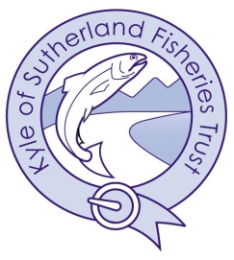

Kyle of Sutherland Rivers Trust
Annual General Meeting

Thursday 12th June 2025 at 1730hrs
Kyle Fisheries Office, Ardgay &
By Video Conference

AGENDA

- Welcome & Apologies
- Approval of minutes of AGM held 12th June 2024
- Actions points & Matters Arising
- Chairman’s Report
- Director’s Report
- Adoption of Draft Accounts to year end 31st December 2024
- Election of Trustees
- Appointment of Auditors / Company Secretary
- AOCB

Next Meeting TBC

