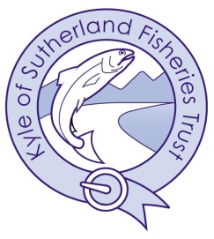

Kyle of Sutherland Rivers Trust
Trust Ordinary Meeting
Thursday 12th June 2025 at 1800hrs
Kyle Fisheries Office, Ardgay &
By Video Conference

AGENDA

- Welcome & Apologies
- Approval of minutes of meeting held on 27th March 2025
- Actions Points & Matters Arising
- Director’s Report
- Budgets 2025
- Auction 2025
- Projects

      - Riverwoods
      - Smolt trapping
      - Merkland restoration plan
      - CBEC projects

- AOB

