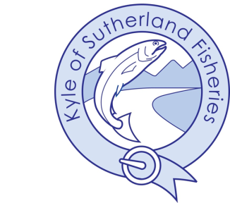

Kyle of Sutherland District Salmon Fishery Board

Conservation policy
By law, it is illegal to retain salmon and grilse caught in Scotland before 1st April.
All salmon must be returned before this date, including fatally damaged fish.
By law, it is illegal to retain salmon and grilse in the Evelix catchment plus tidal and coastal
waters inland to grid reference NH 260930 891210 (approximately 300m downstream of
the bridge in Bonar Bridge during the ebb tide).

Salmon
Aim to achieve:
• A 100% release rate, catchment-wide, over the season.
• A salmon is defined as being a fish of 65 cm (approximately 7 lbs) and over, measuring from the nose to the fork of the tail.

Grilse
Aim to achieve:
• All fish released before 15th June.
• A minimum of 95% release rate, catchment-wide, over the season.

Sea Trout
Aim to achieve:
• All fish released before 15th of June.
• All fish 50 cm (approximately 3 lbs) and over, measuring from the nose to the fork of
the tail, released.
• A minimum of 90% release rate, catchment-wide, over the season.

Method
• Fly only by statutory instrument.
• Treble hooks prohibited.
• Barbless hooks should be used as best practice.

In high temperatures
• If the water temperature exceeds 18˚C, it is recommended that fishing ceases.
• During spells of abnormally warm weather it is recommended that fishing is restricted
to the early hours of the morning before water temperature rises to 18˚C.
• This is a welfare issue for fish. In high temperatures water holds less oxygen, and can
decrease survival rates for released fish.

